Neal Vander Does

Final Project Documentation

12/15/2024

**Initial Proposal from Module 3**

**Step 1 Communication:**

I am working alone on this project so a communication plan does not apply.

**Step 2: Project Description:**

* Client: The Green Bay Packers organization.
* Scope: I want my GUI to be able to display the roster sorted by position group, per game stats for the team, and individual player stats for this season. I may think of other small additions while making it.
* Purpose: The main purpose is completion of my project, but I am a big Packers fan, so I thought it would be nice to have a thing designed by me that shows a bunch of specific data from the 2024-25 season.

**Step 3 - Project Collaboration:**

GitHub link: <https://github.com/NealVanderDoes/Final-Project-SDEV-220>

NEW Trello link: <https://trello.com/b/4RG52Gwv/sdev-220-final-project>

**Step 4- Project Management and Roles:**

Since it is a solo project, I will be doing everything. Do I still have to use a Trello board?

If you have any advice or thoughts about other features I could include, please let me know.

**Class Diagram**

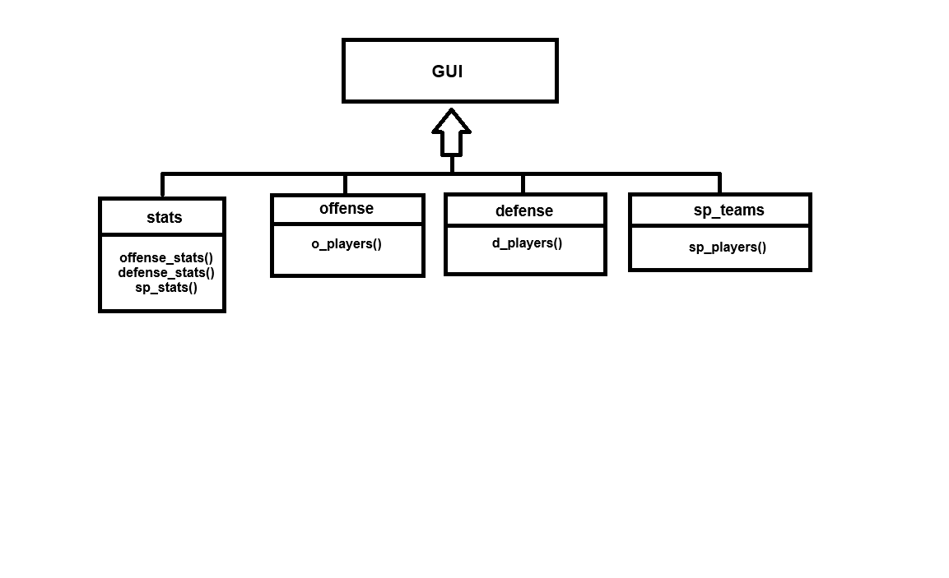

**Results With Sample Output**

If the “Offense” button is clicked on the left-hand categories then the “Quarterback” button is clicked on the top bar, the result gives the stats for the total season up to the current NFL week.

Example: Quarterbacks

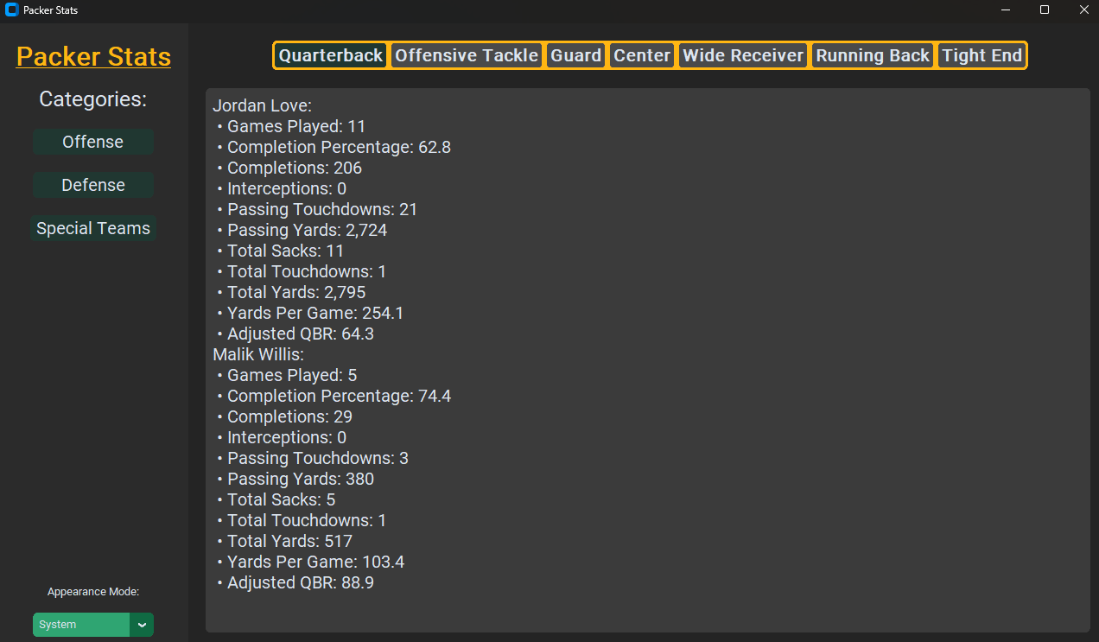

The same applies if each other position group on the top bar is clicked after the “Offense” button is clicked.

Example: Offensive Tackle, Guard, Center (Pretty much no stats are kept for the O-line)

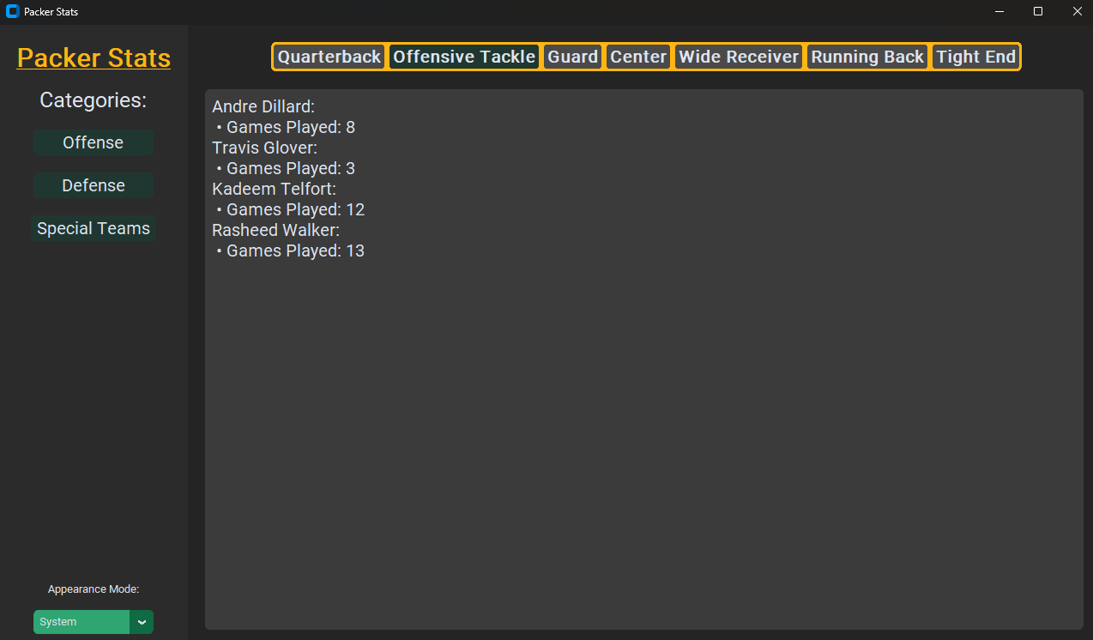

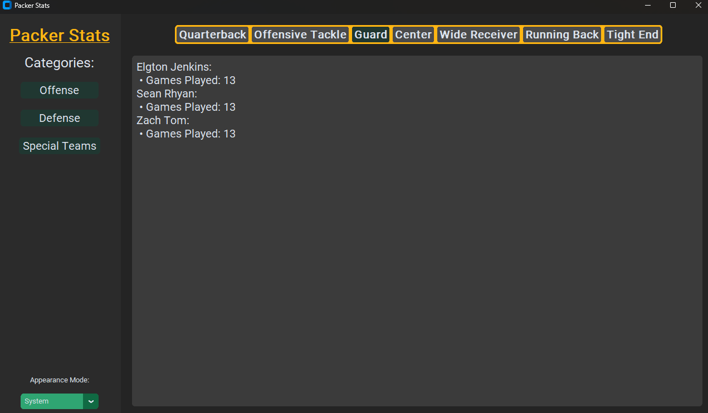

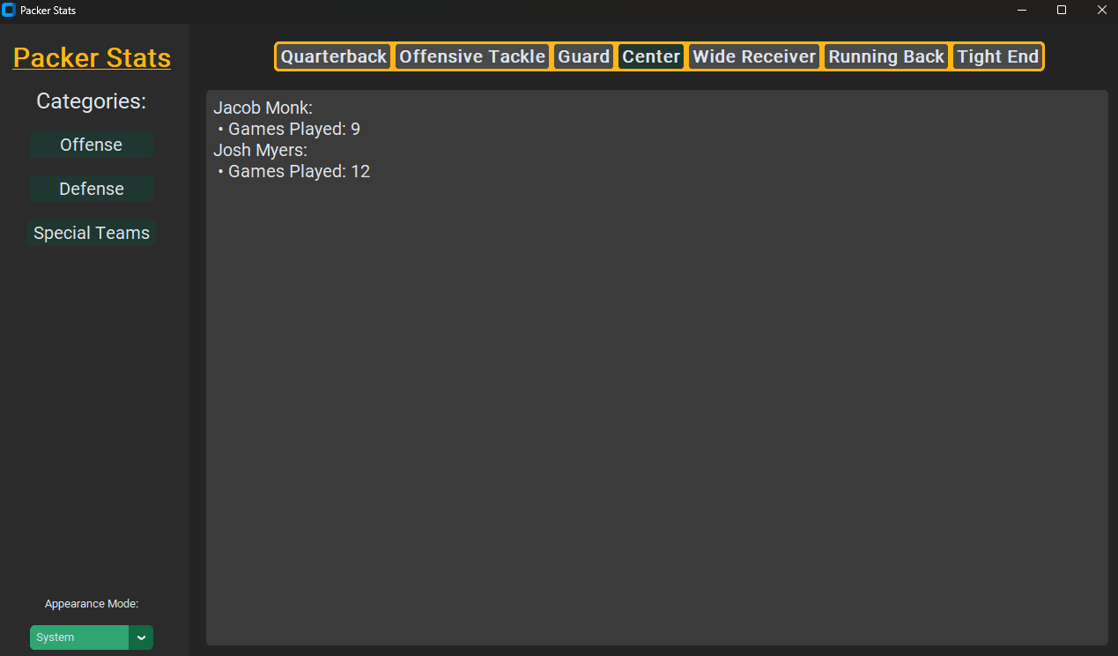

Example: Wide Receiver

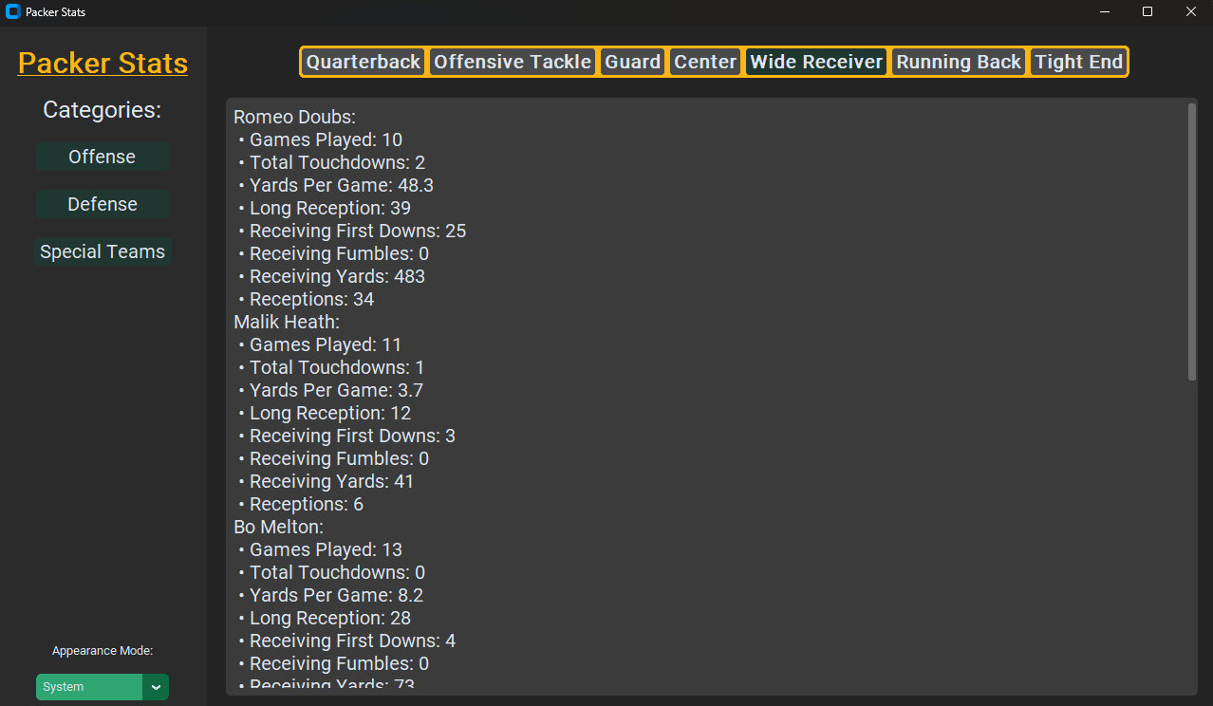

Notice the scroll bar that appeared on the right-hand side in the picture. Position groups with many stats as well as players may require scrolling.

To switch category simply click another category on the left-hand side.

If you were to click “Defense” then select a position like “Cornerback,” it will display the stats for the cornerbacks. This applies to each position group.

Example: Cornerbacks

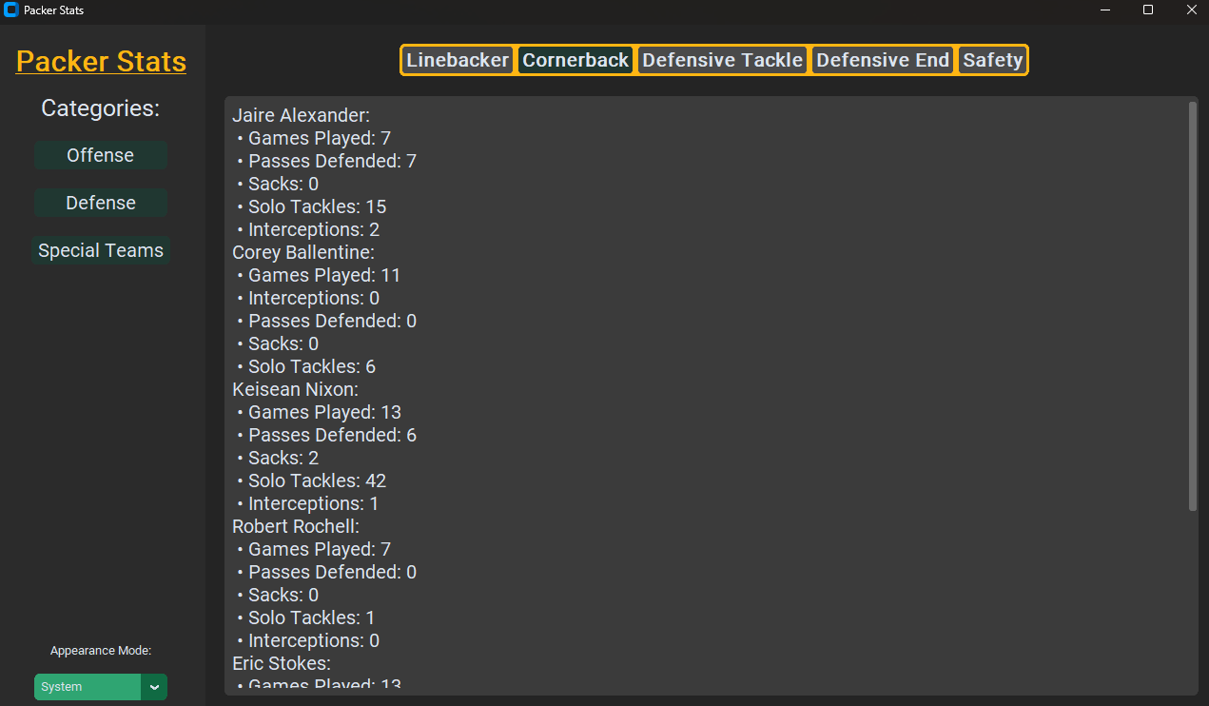

If you wanted to switch to light mode or dark mode, click the button under “Appearance Mode” on the left-hand side. The default is set to your system’s preference.

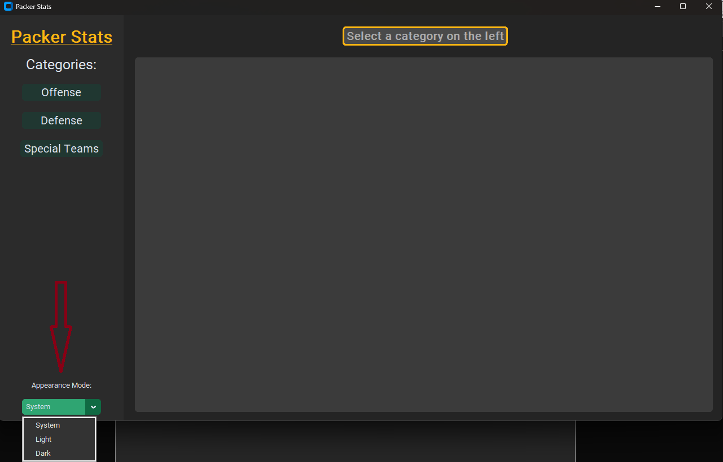

My default system is set to dark mode, if I were to click “Light” I would see the GUI in light mode. (To switch back simply pick “System” or “Dark”)

Example: Light Mode

